**PRACTICAL 3**

**AIM:** To create the following topology.

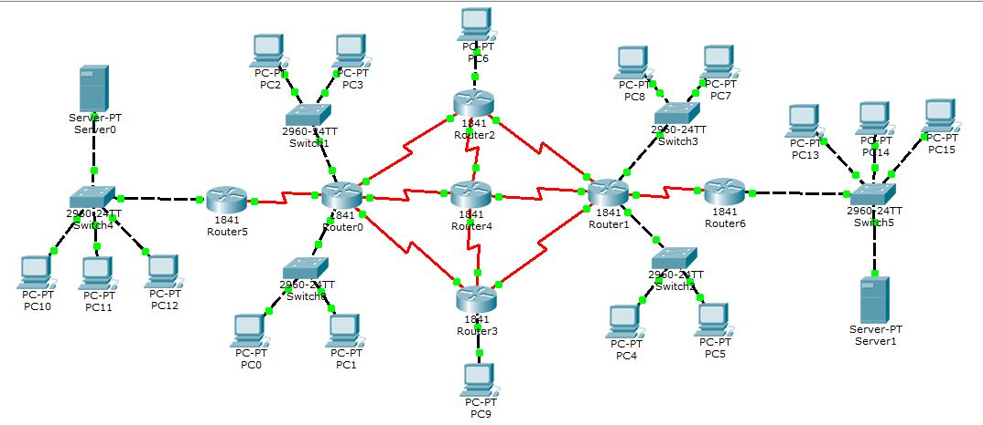

**PC Configuration:**

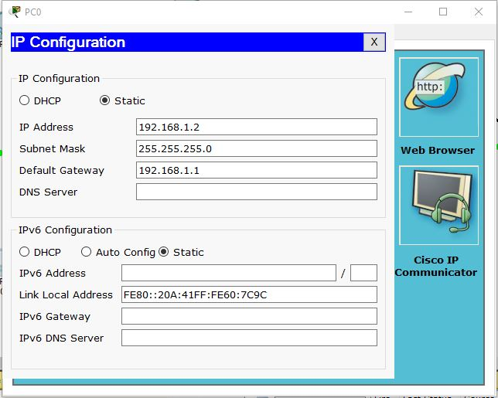

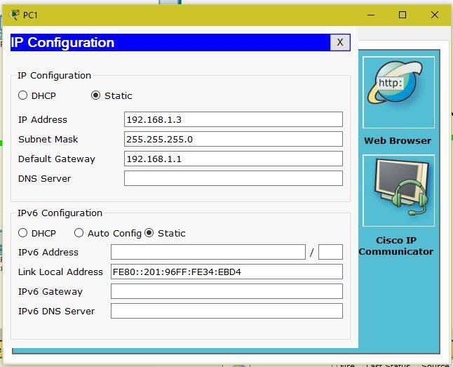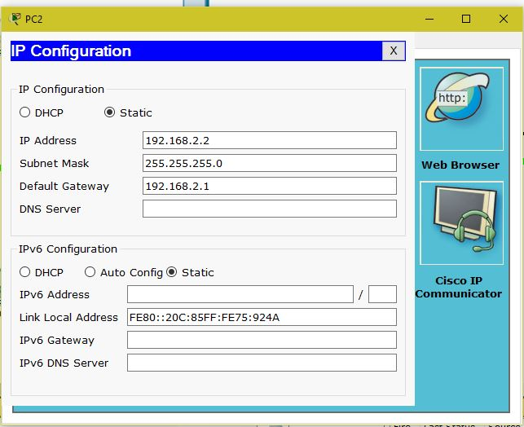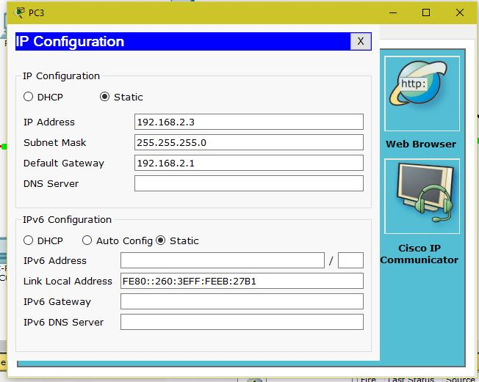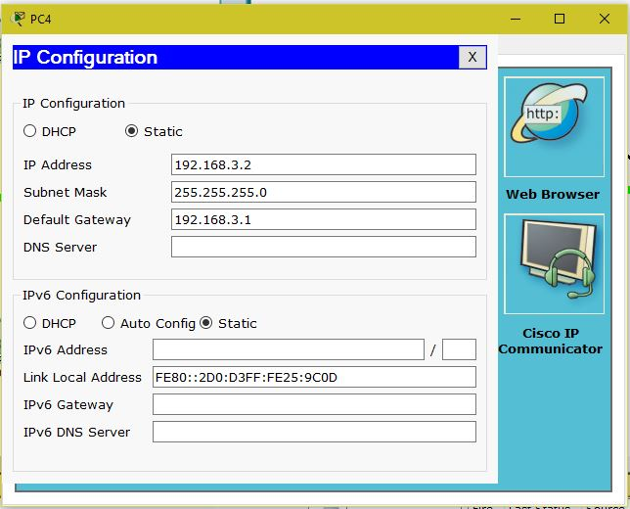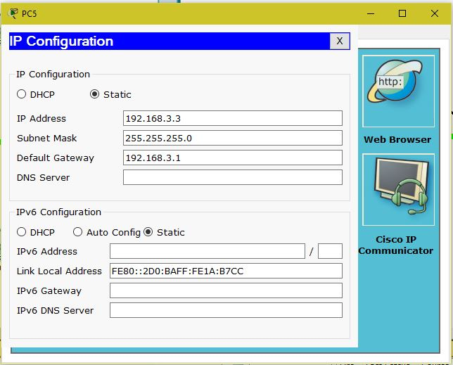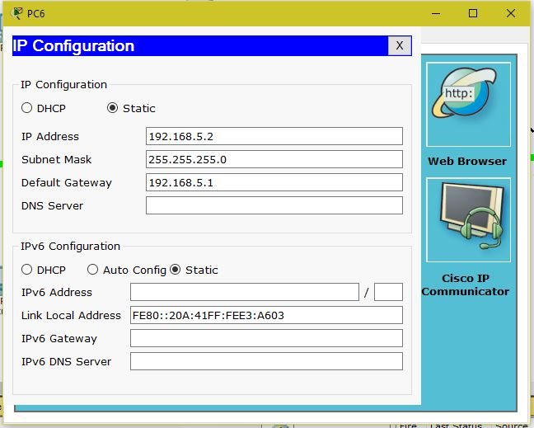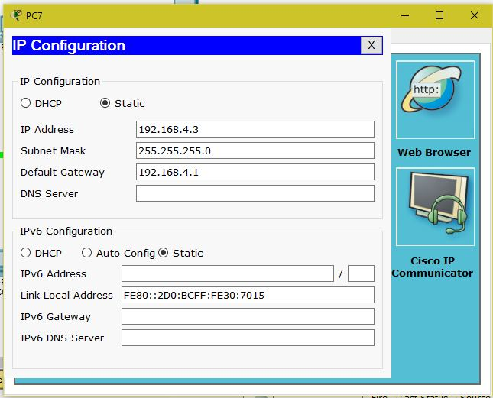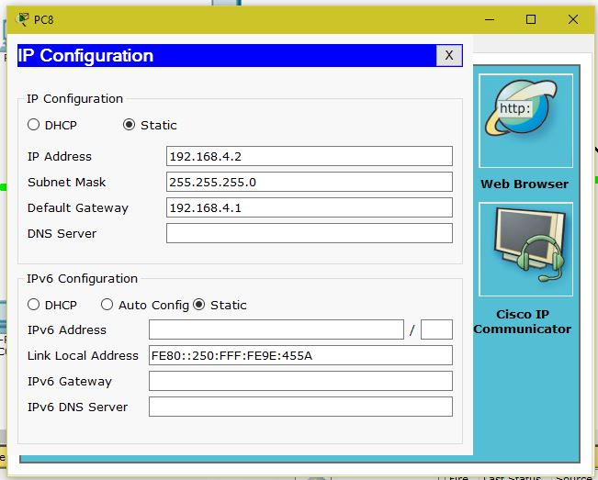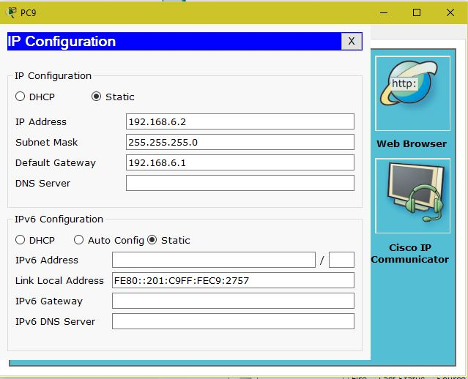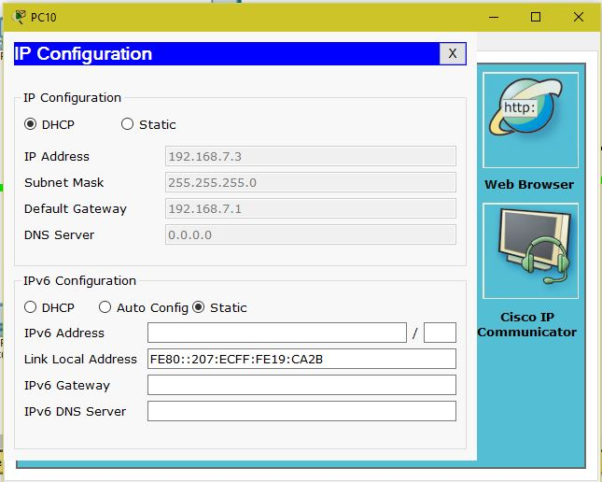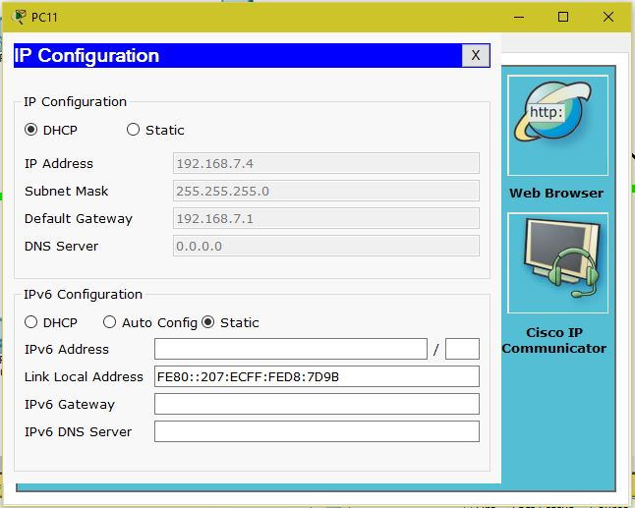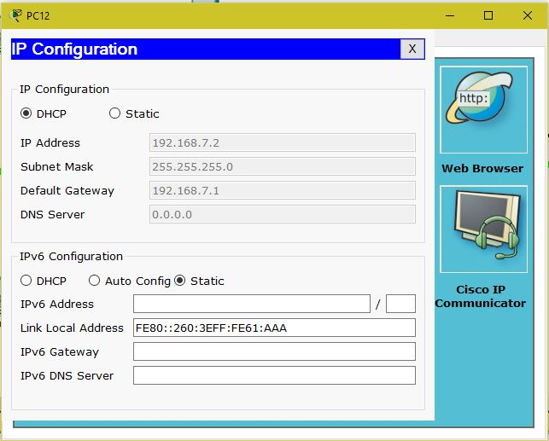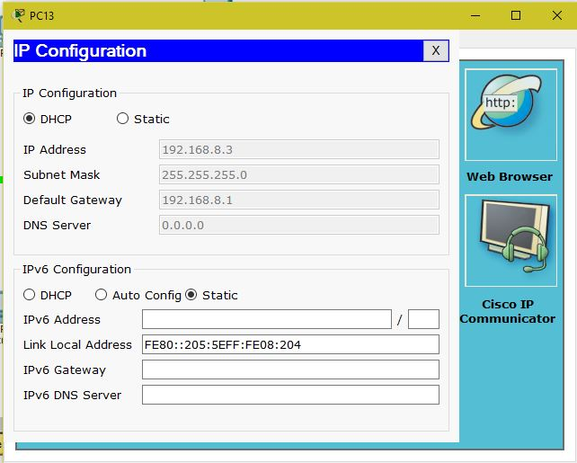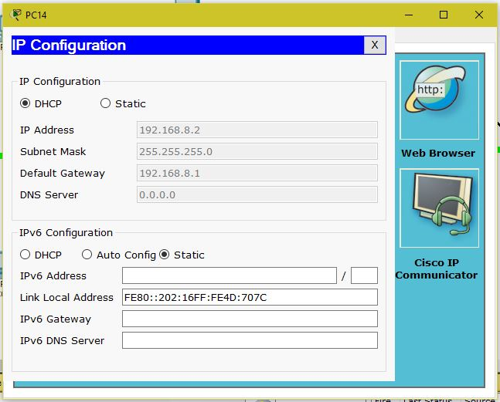

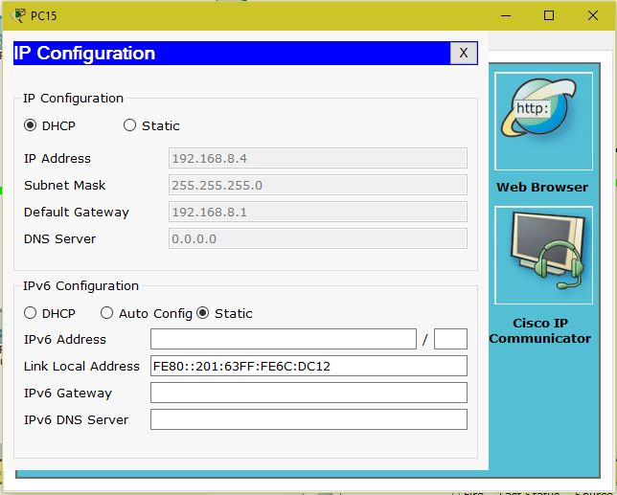

**Server Configuration:**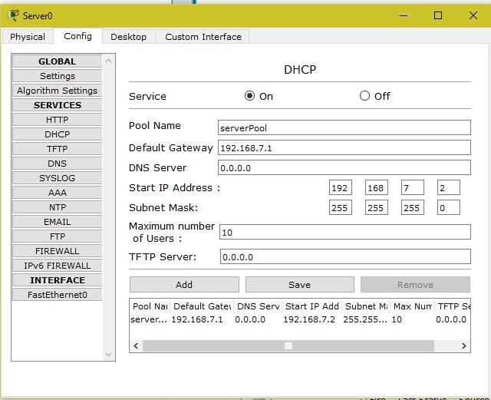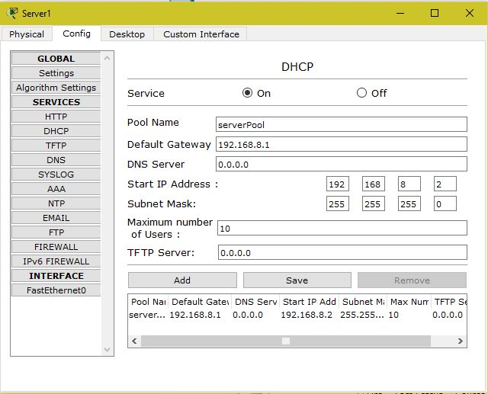

**Router Configuration:**

**Router0:**

Router>enable

Router#configure terminal

Enter configuration commands, one per line. End with CNTL/Z.

Router(config)#interface FastEthernet0/1

Router(config-if)#ip address 192.168.1.1 255.255.255.0

Router(config-if)#no shutdown

Router(config-if)#

%LINK-5-CHANGED: Interface FastEthernet0/1, changed state to up

%LINEPROTO-5-UPDOWN: Line protocol on Interface FastEthernet0/1, changed state to up

Router(config-if)#exit

Router(config)#interface Serial0/0/0

Router(config-if)#ip address 192.168.11.1 255.255.255.0

Router(config-if)#clock rate 72000

Router(config-if)#no shutdown

Router(config-if)#exit

Router(config)#interface Serial0/0/1

Router(config-if)#ip address 192.168.12.1 255.255.255.0

Router(config-if)#clock rate 72000

Router(config-if)#no shutdown

Router(config-if)#

Router(config-if)#exit

Router(config)#interface Serial0/1/0

Router(config-if)#ip address 192.168.13.1 255.255.255.0

Router(config-if)#clock rate 72000

Router(config-if)#no shutdown

Router(config-if)#

Router(config-if)#exit

Router(config)#interface Serial0/1/1

Router(config-if)#ip address 192.168.14.1 255.255.255.0

Router(config-if)#clock rate 72000

Router(config-if)#no shutdown

Router(config-if)#

Router(config-if)#exit

Router(config)#interface FastEthernet0/0

Router(config-if)#ip address 192.168.2.1 255.255.255.0

Router(config-if)#no shutdown

Router(config-if)#

%LINK-5-CHANGED: Interface FastEthernet0/0, changed state to up

%LINEPROTO-5-UPDOWN: Line protocol on Interface FastEthernet0/0, changed state to up

**Router1:**

Router>enable

Router#configure terminal

Enter configuration commands, one per line. End with CNTL/Z.

Router(config)#interface FastEthernet0/0

Router(config-if)#ip address 192.168.4.1 255.255.255.0

Router(config-if)#no shutdown

%LINK-5-CHANGED: Interface FastEthernet0/0, changed state to up

%LINEPROTO-5-UPDOWN: Line protocol on Interface FastEthernet0/0, changed state to up

Router(config-if)#exit

Router(config)#interface FastEthernet0/1

Router(config-if)#ip address 192.168.3.1 255.255.255.0

Router(config-if)#no shutdown

Router(config-if)#

%LINK-5-CHANGED: Interface FastEthernet0/1, changed state to up

%LINEPROTO-5-UPDOWN: Line protocol on Interface FastEthernet0/1, changed state to up

Router(config-if)#exit

Router(config)#interface Serial0/0/0

Router(config-if)#ip address 192.168.15.1 255.255.255.0

Router(config-if)#clock rate 72000

Router(config-if)#no shutdown

Router(config-if)#

Router(config-if)#exit

Router(config)#interface Serial0/0/1

Router(config-if)#ip address 192.168.16.1 255.255.255.0

Router(config-if)#no shutdown

Router(config-if)#clock rate 72000

This command applies only to DCE interfaces

Router(config-if)#no shutdown

Router(config-if)#

Router(config-if)#exit

Router(config)#interface Serial0/1/0

Router(config-if)#ip address 192.168.17.1 255.255.255.0

Router(config-if)#clock rate 72000

This command applies only to DCE interfaces

Router(config-if)#no shutdown

Router(config-if)#

Router(config-if)#exit

Router(config)#interface Serial0/1/1

Router(config-if)#ip address 192.168.18.1 255.255.255.0

Router(config-if)#clock rate 72000

This command applies only to DCE interfaces

Router(config-if)#no shutdown

**Router2:**

Router>enable

Router#configure terminal

Enter configuration commands, one per line. End with CNTL/Z.

Router(config)#interface FastEthernet0/0

Router(config-if)#ip address 192.168.5.1 255.255.255.0

Router(config-if)#no shutdown

Router(config-if)#

%LINK-5-CHANGED: Interface FastEthernet0/0, changed state to up

%LINEPROTO-5-UPDOWN: Line protocol on Interface FastEthernet0/0, changed state to up

Router(config-if)#exit

Router(config)#interface Serial0/1/0

Router(config-if)#ip address 192.168.13.2 255.255.255.0

Router(config-if)#clock rate 72000

This command applies only to DCE interfaces

Router(config-if)#no shutdown

Router(config-if)#

%LINK-5-CHANGED: Interface Serial0/1/0, changed state to up

%LINEPROTO-5-UPDOWN: Line protocol on Interface Serial0/1/0, changed state to up

Router(config-if)#exit

Router(config)#interface Serial0/1/1

Router(config-if)#ip address 192.168.18.2 255.255.255.0

Router(config-if)#clock rate 72000

Router(config-if)#no shutdown

Router(config-if)#

%LINK-5-CHANGED: Interface Serial0/1/1, changed state to up

%LINEPROTO-5-UPDOWN: Line protocol on Interface Serial0/1/1, changed state to up

Router(config-if)#exit

Router(config)#interface Serial0/0/0

Router(config-if)#ip address 192.168.19.1 255.255.255.0

Router(config-if)#clock rate 72000

Router(config-if)#no shutdown

Router(config-if)#

Router(config-if)#exit

Router(config)#interface Serial0/0/0

Router(config-if)#

Router(config-if)#exit

**Router3:**

Router>enable

Router#configure terminal

Enter configuration commands, one per line. End with CNTL/Z.

Router(config)#interface FastEthernet0/0

Router(config-if)#ip address 192.168.6.1 255.255.255.0

Router(config-if)#no shutdown

Router(config-if)#

%LINK-5-CHANGED: Interface FastEthernet0/0, changed state to up

Router(config-if)#exit

Router(config)#interface Serial0/0/0

Router(config-if)#ip address 192.168.11.2 255.255.255.0

Router(config-if)#clock rate 72000

This command applies only to DCE interfaces

Router(config-if)#no shutdown

Router(config-if)#

%LINK-5-CHANGED: Interface Serial0/0/0, changed state to up

%LINEPROTO-5-UPDOWN: Line protocol on Interface Serial0/0/0, changed state to up

Router(config-if)#exit

Router(config)#interface Serial0/0/1

Router(config-if)#ip address 192.168.20.2 255.255.255.0

Router(config-if)#clock rate 72000

This command applies only to DCE interfaces

Router(config-if)#no shutdown

Router(config-if)#

%LINK-5-CHANGED: Interface Serial0/0/1, changed state to up

%LINEPROTO-5-UPDOWN: Line protocol on Interface Serial0/0/1, changed state to up

Router(config-if)#exit

Router(config)#interface Serial0/1/1

Router(config-if)#ip address 192.168.16.2 255.255.255.0

Router(config-if)#clock rate 72000

Router(config-if)#no shutdown

Router(config-if)#

%LINK-5-CHANGED: Interface Serial0/1/1, changed state to up

%LINEPROTO-5-UPDOWN: Line protocol on Interface Serial0/1/1, changed state to up

**Router4:**

Router>enable

Router#configure terminal

Enter configuration commands, one per line. End with CNTL/Z.

Router(config)#interface Serial0/1/1

Router(config-if)#ip address 192.168.14.2 255.255.255.0

Router(config-if)#clock rate 72000

This command applies only to DCE interfaces

Router(config-if)#no shutdown

Router(config-if)#

%LINK-5-CHANGED: Interface Serial0/1/1, changed state to up

%LINEPROTO-5-UPDOWN: Line protocol on Interface Serial0/1/1, changed state to up

Router(config-if)#exit

Router(config)#interface Serial0/0/0

Router(config-if)#ip address 192.168.19.2 255.255.255.0

Router(config-if)#clock rate 72000

This command applies only to DCE interfaces

Router(config-if)#no shutdown

Router(config-if)#

%LINK-5-CHANGED: Interface Serial0/0/0, changed state to up

%LINEPROTO-5-UPDOWN: Line protocol on Interface Serial0/0/0, changed state to up

Router(config-if)#exit

Router(config)#interface Serial0/1/0

Router(config-if)#ip address 192.168.17.2 255.255.255.0

Router(config-if)#clock rate 72000

Router(config-if)#no shutdown

Router(config-if)#

%LINK-5-CHANGED: Interface Serial0/1/0, changed state to up

%LINEPROTO-5-UPDOWN: Line protocol on Interface Serial0/1/0, changed state to up

Router(config-if)#exit

Router(config)#interface Serial0/0/1

Router(config-if)#ip address 192.168.20.1 255.255.255.0

Router(config-if)#clock rate 72000

Router(config-if)#no shutdown

**Router5:**

Router>enable

Router#configure terminal

Enter configuration commands, one per line. End with CNTL/Z.

Router(config)#interface FastEthernet0/0

Router(config-if)#ip address 192.168.7.1 255.255.255.0

Router(config-if)#no shutdown

Router(config-if)#

%LINK-5-CHANGED: Interface FastEthernet0/0, changed state to up

%LINEPROTO-5-UPDOWN: Line protocol on Interface FastEthernet0/0, changed state to up

Router(config-if)#exit

Router(config)#interface Serial0/0/1

Router(config-if)#ip address 192.168.12.2 255.255.255.0

Router(config-if)#clock rate 72000

This command applies only to DCE interfaces

Router(config-if)#no shutdown

Router(config-if)#

%LINK-5-CHANGED: Interface Serial0/0/1, changed state to up

Router(config-if)#

%LINEPROTO-5-UPDOWN: Line protocol on Interface Serial0/0/1, changed state to up

**Router6:**

Router>enable

Router#configure terminal

Enter configuration commands, one per line. End with CNTL/Z.

Router(config)#interface FastEthernet0/0

Router(config-if)#ip address 192.168.8.1 255.255.255.0

Router(config-if)#no shutdown

Router(config-if)#

%LINK-5-CHANGED: Interface FastEthernet0/0, changed state to up

%LINEPROTO-5-UPDOWN: Line protocol on Interface FastEthernet0/0, changed state to up

Router(config-if)#exit

Router(config)#interface Serial0/0/0

Router(config-if)#ip address 192.168.15.2 255.255.255.0

Router(config-if)#clock rate 72000

This command applies only to DCE interfaces

Router(config-if)#no shutdown

Router(config-if)#

%LINK-5-CHANGED: Interface Serial0/0/0, changed state to up

Router(config-if)#

%LINEPROTO-5-UPDOWN: Line protocol on Interface Serial0/0/0, changed state to up

**IP Router:**

**Router0:**

Router(config)#router rip

Router(config-router)#network 192.168.1.0

Router(config-router)#network 192.168.2.0

Router(config-router)#network 192.168.11.0

Router(config-router)#network 192.168.12.0

Router(config-router)#network 192.168.13.0

Router(config-router)#network 192.168.14.0

**Router1:**

Router(config-router)#network 192.168.3.0

Router(config-router)#network 192.168.4.0

Router(config-router)#network 192.168.15.0

Router(config-router)#network 192.168.16.0

Router(config-router)#network 192.168.17.0

Router(config-router)#network 192.168.18.0

**Router2:**

Router(config)#router rip

Router(config-router)#network 192.168.5.0

Router(config-router)#network 192.168.13.0

Router(config-router)#network 192.168.15.0

Router(config-router)#network 192.168.18.0

Router(config-router)#no network 192.168.15.0

Router(config-router)#network 192.168.19.0

**Router3:**

Router(config)#router rip

Router(config-router)#network 192.168.6.0

Router(config-router)#network 192.168.11.0

Router(config-router)#network 192.168.16.0

Router(config-router)#network 192.168.20.0

**Router4:**

Router(config)#router rip

Router(config-router)#network 192.168.14.0

Router(config-router)#network 192.168.17.0

Router(config-router)#network 192.168.19.0

Router(config-router)#network 192.168.20.0

**Router5:**

Router(config)#router rip

Router(config-router)#network 192.168.7.0

Router(config-router)#network 192.168.12.0

**Router6:**

Router(config)#router rip

Router(config-router)#network 192.168.18.0

Router(config-router)#network 192.168.15.0

**Output:**